Roles and Environments

**What is a Role?**

In your organization, if your infrastructure grows to meet the demands of higher traffic, there are likely to be multiple, redundant servers that all perform the same basic tasks. For instance, these might be web servers that a load balancer passes requests to. They would all have the same basic configuration and could be said to each satisfy the same "role".

Chef's view of **roles** is almost entirely the same as the regular definition. A role in Chef is a categorization that describes what a specific machine is supposed to *do*. What responsibilities does it have and what software and settings should be given to it.

In different situations, you may have certain machines handling more than one role. For instance, if you are testing your software, one server may include the database and web server components, while in production, you plan on having these on separate servers.

With Chef, this can be as easy as assigning the first server to both roles and then assigning each role to separate computers for your production machines. Each role will contain the configuration details necessary to bring the machine to a fully operational state to fulfill its specific role. This means you can gather cookbooks that will handle package installations, service configuration, special attributes for that role, etc.

**What is an Environment?**

Related to the idea of a role is the concept of Chef **environments**. An environment is simply a designation meant to help an administrator know what stage of the production process a server is a part of. Each server can be part of exactly one environment.

By default, an environment called "_default" is created. Each node will be placed into this environment unless another environment is specified. Environments can be created to tag a server as part of a process group.

For instance, one environment may be called "testing" and another may be called "production". Since you don't want any code that is still in testing on your production machines, each machine can only be in one environment. You can then have one configuration for machines in your testing environment, and a completely different configuration for computers in production.

In the above example given in roles, you could specify that in your testing environment, the web and database server roles will be on a single machine. In your production environment, these roles should be tackled by individual servers.

Environments also help with the testing process itself. You can specify that in production, a cookbook should be a stable version. However, you can specify that if a machine is part of the testing environment, it can receive a more recent version of the cookbook.

How To Use Roles

**Create a Role Using the Ruby DSL**

We can create roles using the roles directory in our chef-repo directory on our workstation.

Log into your workstation and move into this directory now:

cd ~/chef-repo/roles

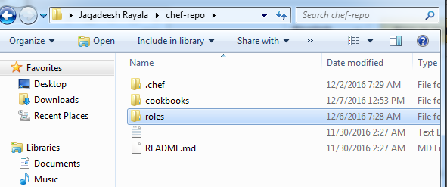

Create a file **Webserver.rb** under **roles** folder

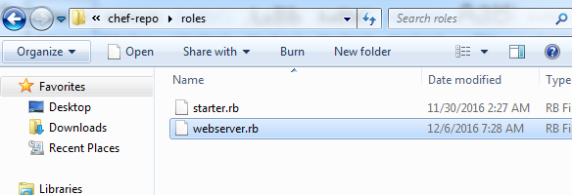

Once create the file open with note pad or your favorite editor

Write below code

name "webserver"

description "for webservers"

run_list "recipe[Sample]","recipe[web]"

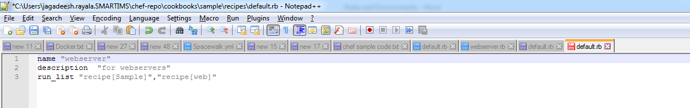

Save and upload file to chef server

To check roles on server

**C:\Users\jagadeesh.rayala.SMARTIMS\chef-repo>knife role list**



To upload roles to server first go to roles folder and upload

**C:\Users\jagadeesh.rayala.SMARTIMS\chef-repo>cd roles**

**C:\Users\jagadeesh.rayala.SMARTIMS\chef-repo\roles>knife role upload from file webserver.rb**

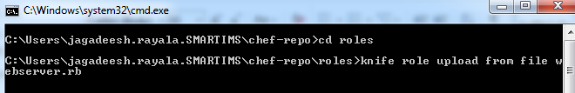

Once uploaded to server check.

Login to server and check on roles

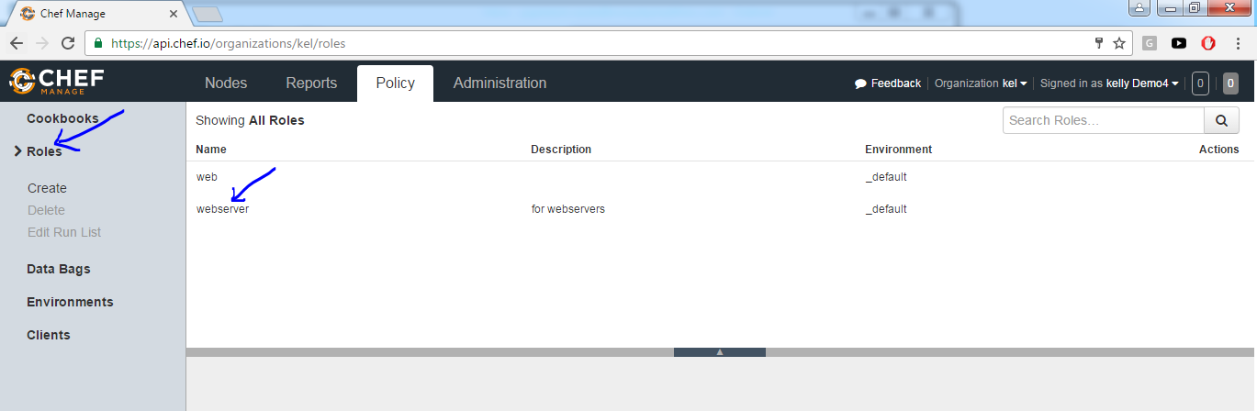

# **Graphically create role on server**

Login to chef server

Go to Policy 🡪roles🡪create

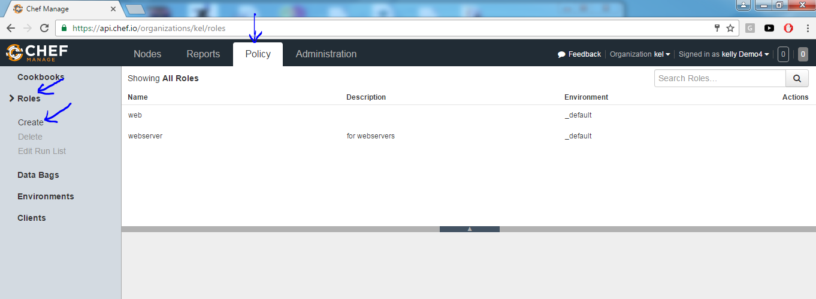

Give role name and click on next

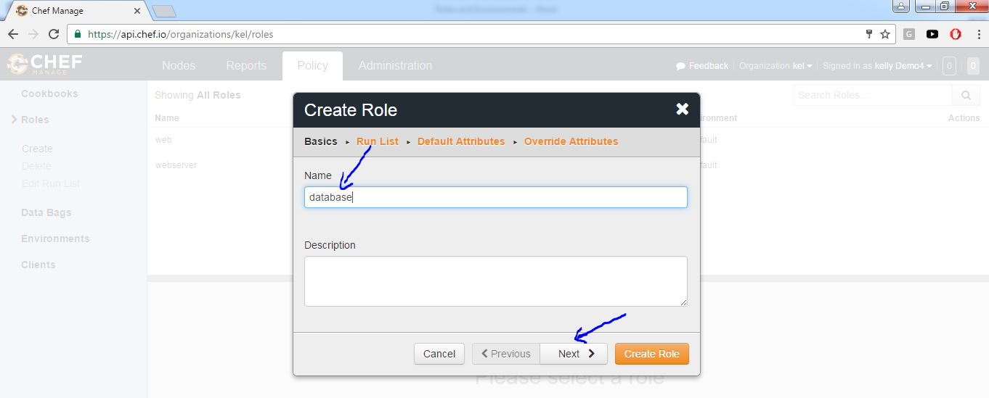

IN second box Available recipes choose your cook book and drag to Current Run List on right side box as below shown

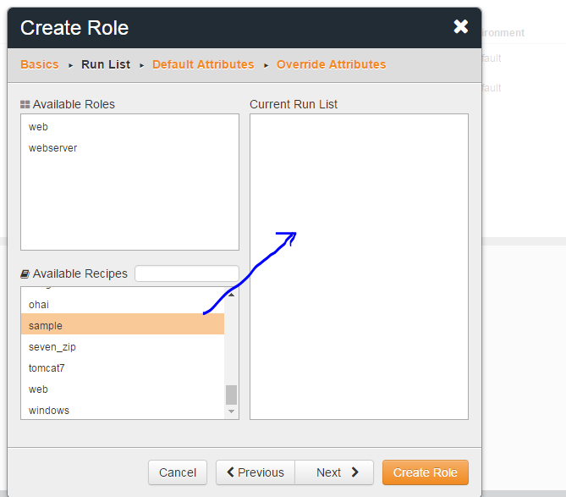

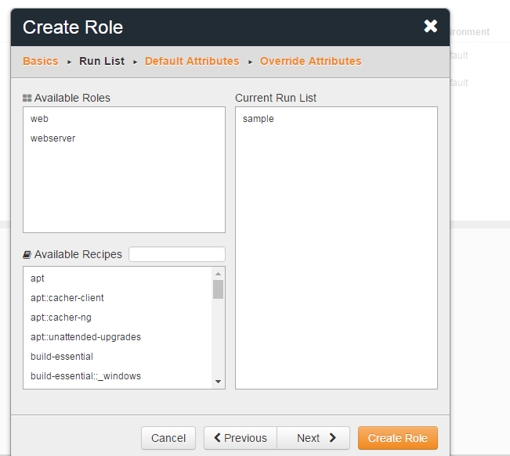

Then click on Create Role button.

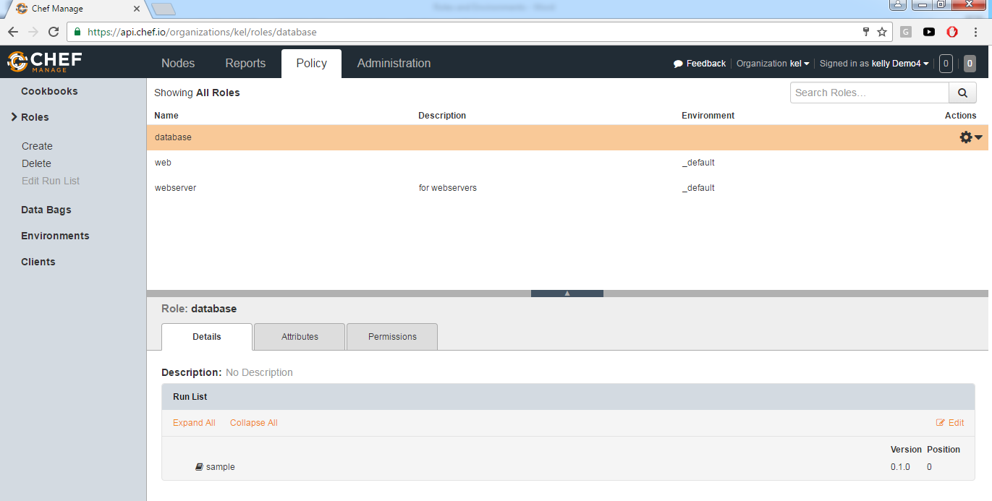

To delete or Edit Role

Select role and click on right side Actions button

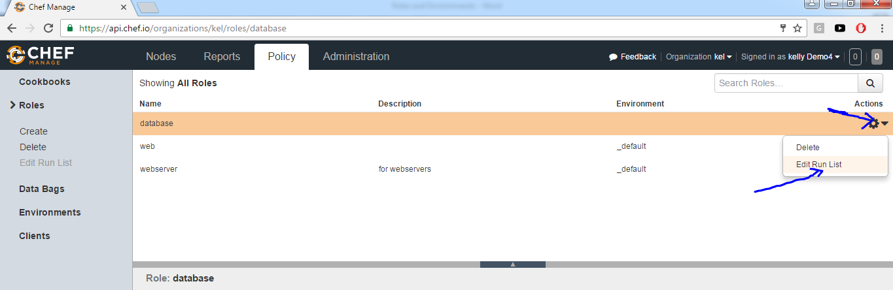

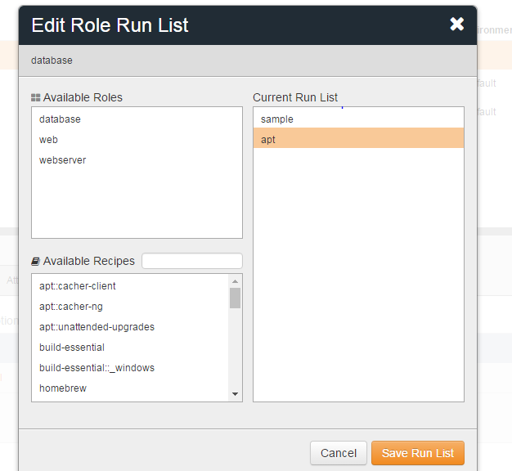

Select from Available Recipes drag to Current Run List as shown above, Then Save Run List.